**Smart Waste Management System for Metropolitan**

**Cities**

**ASSIGNMENT 4**

|  |  |
| --- | --- |
| ASSIGNMENT | 4 |
| Date | 24 October 2022 |
| Team ID | PNT2022TMID42279 |
| Project Name | **Smart Waste Management System for**  **Metropolitan Cities** |

**ASSIGNMENT 4**:

Write code and connections in wokwi for ultrasonic sensors.

Whenever distance is less than 100 cms send "alert" to ibm cloud and display in device recent events.

Upload document with wokwi share link and images of ibm cloud

**CODE**

**#include <Wifi.h>**

**#include <PubSubClient.h>**

**WiFiClient wifiClient;**

**#define ORG "o1z9pr"**

**#define DEVICE_TYPE "raspberrypi"**

**#define DEVICE_ID "USE YOUR ID"**

**#define TOKEN "USE YOUR TOKEN"**

**#define speed 0.034**

**char server[] = ORG**

**".messaging.internetofthings.ibmcloud.com";**

**char publishTopic[] = "iot-2/evt/raspberrypi_1/fmt/json";**

**char topic[] = "iot-2/cmd/home/fmt/String";**

**char authMethod[] = "use-token-auth"; char token[] = TOKEN;**

**char clientId[] = "d:" ORG ":" DEVICE_TYPE ":" DEVICE_ID; PubSubClient client(server, 1883, wifiClient);**

**void publishData();**

**const int trigpin=5; const int echopin=18;**

**String command; String data="";**

**long duration;**

**float dist;**

**void setup()**

**{**

**Serial.begin(115200);**

**pinMode(trigpin, OUTPUT);**

**pinMode(echopin, INPUT);**

**wifiConnect();**

**mqttConnect();**

**}**

**void loop()**

**{**

**publishData();**

**delay(+500);**

**if (!client.loop())**

**{**

**mqttConnect();**

**}**

**}**

**void wifiConnect()**

**{**

**Serial.print("Connecting to ");**

**Serial.print("Wifi");**

**WiFi.begin("Wokwi-GUEST", "", 6);**

**while (WiFi.status() != WL_CONNECTED)**

**{**

**delay(500);**

**Serial.print(".");**

**}**

**Serial.print("WiFi connected, IP address: ");**

**Serial.println(WiFi.localIP());**

**}**

**void mqttConnect()**

**{**

**if (!client.connected())**

**{**

**Serial.print("Reconnecting MQTT client to ");**

**Serial.println(server);**

**while (!client.connect(clientId, authMethod, token))**

**{**

**Serial.print(".");**

**delay(500);**

**}**

**initManagedDevice();**

**Serial.println();**

**}**

**}**

**void initManagedDevice()**

**{**

**if (client.subscribe(topic))**

**{**

**// Serial.println(client.subscribe(topic));**

**Serial.println("subscribe to cmd OK");**

**}**

**else**

**{**

**Serial.println("subscribe to cmd FAILED");**

**}**

**}**

**void publishData()**

**{**

**digitalWrite(trigpin,LOW);**

**digitalWrite(trigpin,HIGH);**

**delayMicroseconds(10);**

**digitalWrite(trigpin,LOW);**

**duration=pulseIn(echopin,HIGH);**

**dist=duration*speed/2; if(dist<100)**

**{**

**String payload = "{\"Alert distance\":";**

**payload += dist; payload += "}";**

**Serial.print("\n");**

**Serial.print("Sending payload: ");**

**Serial.println(payload);**

**if (client.publish(publishTopic, (char*) payload.c_str()))**

**{**

**Serial.println("Publish OK");**

**}**

**else**

**{**

**Serial.println("Publish FAILED");**

**}**

**}**

**}**

**CONNECTIONS:**

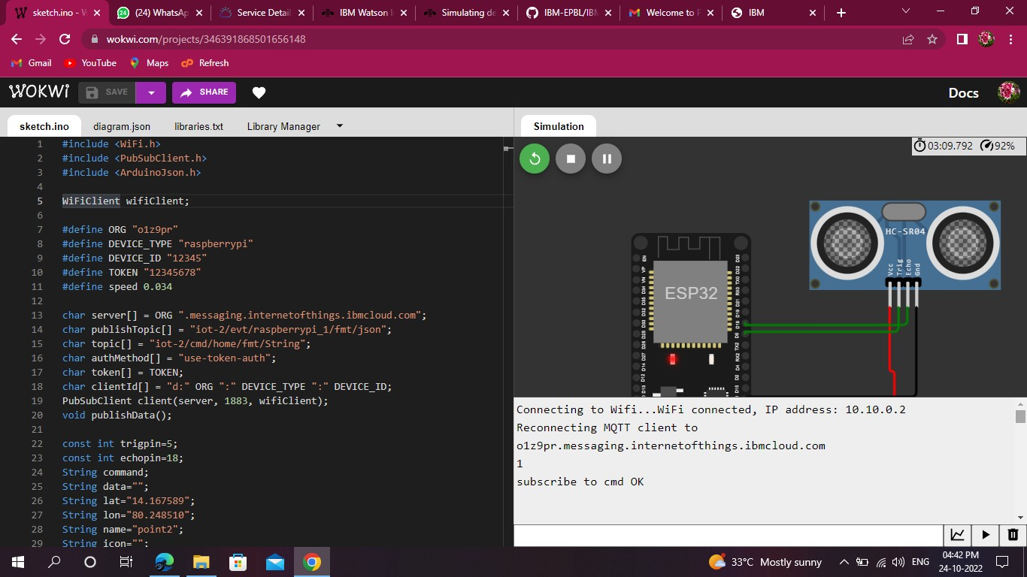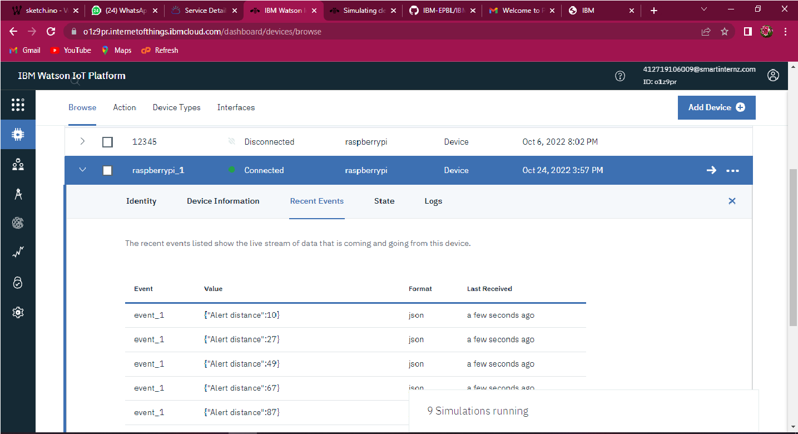

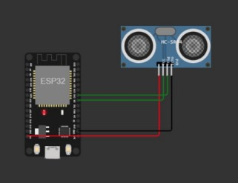

**WOKWI LINK:**

**https://wokwi.com/projects/346391868501656148 OUTPUT:**